# CS 255 System Design Document Template

This template lays out all the different sections that you need to complete for Project Two. Each section has guidance to prompt your thinking. You will need to continually reference the interview transcript as you work to make sure that you are addressing your client’s needs. There is no required length for the final document. Instead the goal is to complete each section based on what your client’s needs are. Remove this note when you are finished, and replace all bracketed text with the relevant information.

## UML Diagrams

### UML Use Case Diagram

*[In Module Six, you were asked to complete a use case diagram based on your system design. If you would like to make any adjustments to your diagram, please do so. Please insert your use case diagram here. Check to make sure that you included appropriate components and symbols and that your design meets the client’s needs.]*

### UML Activity Diagrams

*[You were asked to choose* ***two*** *use cases and create* ***two*** *activity diagrams, one for each use case. Please insert* ***both*** *of your activity diagrams here. Check to make sure that you included appropriate components and symbols and that your design meets the client’s needs.]*

For my first use case, I’ve chosen the Student (Customer) “Register Account” scenario, here is the activity diagram:

For my second use case, I’ve chosen the Student (Customer) purchasing a driving package tier:

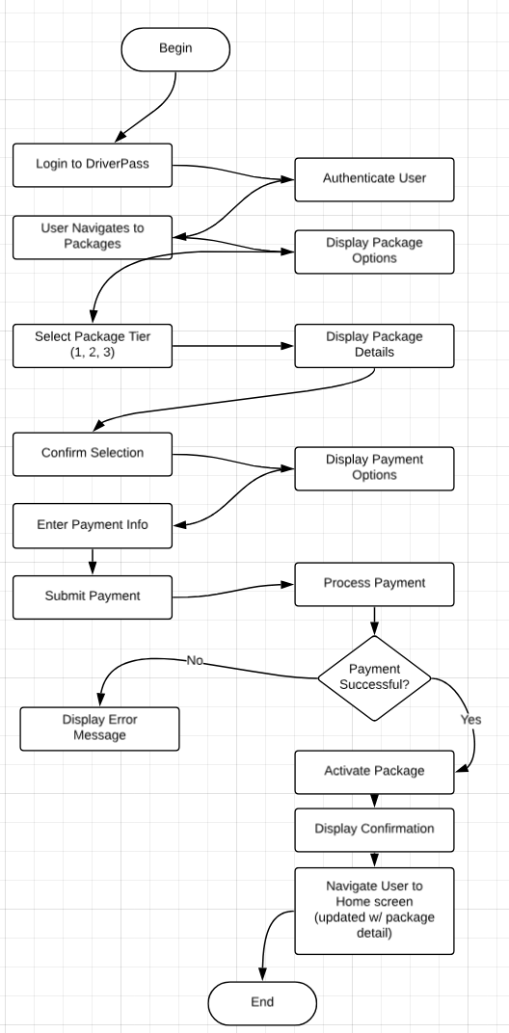

### UML Sequence Diagram

*[You were asked to create a sequence diagram based on* ***one*** *of the use cases you chose. Please insert your sequence diagram here. Check to make sure that you included appropriate components and symbols and that your design meets the client’s needs.]*

(I’ve chosen the Student (Customer) purchasing a driving package tier):

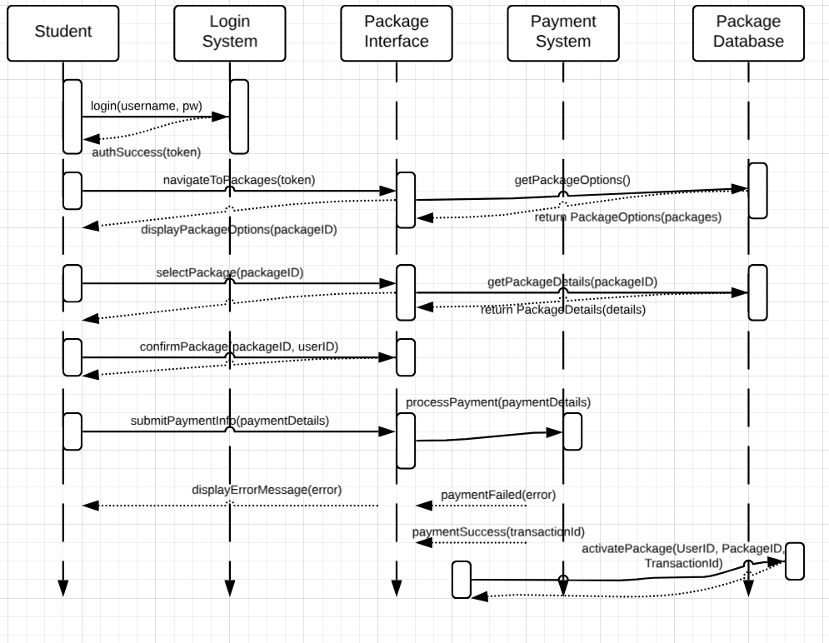

### UML Class Diagram

*[You were asked to create a class diagram based on the different classes and attributes needed for your system design. You are* ***not*** *required to include methods, but you may if you wish. Please insert your class diagram here. Check to make sure that you included appropriate components and symbols and that your design meets the client’s requirements.]*

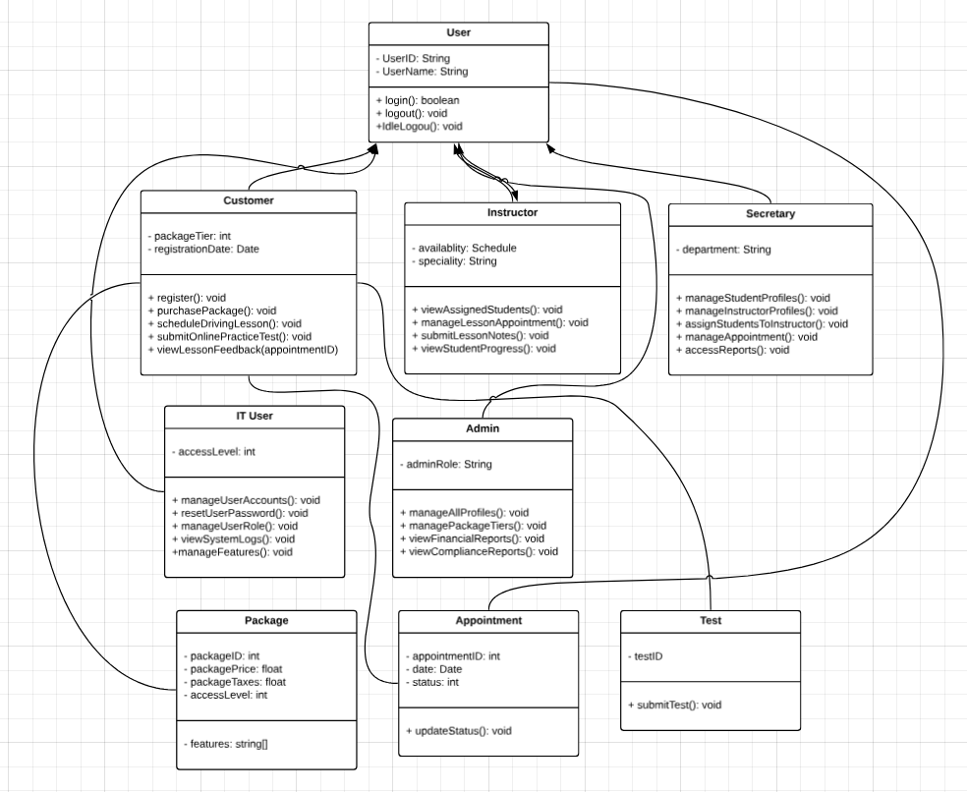

## Technical Requirements

*[Based on the diagrams you have created, describe the technical requirements of your system. These requirements should address the required hardware, software, tools, and infrastructure necessary for your system design.]*

Based on interpretations from the numerous encounters with the DriverPass team here are the technical requirements: Beginning with the login system, the system will require a detailed and modern user authentication and management system, which will include secure user login capabilities, password management, and role-based access control. It will need to support multiple user roles such as Customer (Student), Instructor, Secretary, IT User, and Admin (which ensures appropriate access restrictions based on the user type). The system will also need secure session management and user profile features, including data validation for accurate profile information.

For Customer (Student) management, the system will allow new account registration, tiered package purchasing, and lesson scheduling. Additionally, it will provide an online practice test platform with progress tracking and a feedback viewing system for students to review instructor comments. Instructors will have interfaces to view assigned students, manage appointments, track student progress, and receive notifications for upcoming lessons. The system will also include functionality for instructors to document notes on student progress.

Administrative and IT management features will include interfaces for managing profiles, assigning students to instructors, and modifying appointments. Administrators will have tools for managing package tiers (includes compliance reporting). IT management will involve user account creation, feature management, and logging for security and troubleshooting. The system will rely on a relational database to store critical data, with robust backup functionality, with recovery, and security measures in place. It will also provide secure communication channels, a scalable infrastructure, and performance optimization tools, while ensuring compliance with security and privacy regulations (GDPR). A more comprehensive list of items can be found below:

User Authentication and Management Requirements

1. Implement a secure user authentication system supporting multiple user roles (Customer, Instructor, Secretary, IT User, Admin)
2. Create a password management system with secure reset capabilities (MFA enabled)
3. Develop role-based access control to restrict system features based on user type
4. Include session management for secure login/logout functionality
5. Implement user profile management with appropriate data validation

Customer/Student Management Requirements

1. Design a registration system for new customer accounts
2. Develop a tiered package purchase and management system
3. Create a lesson scheduling interface for customers to book driving lessons
4. Implement an online practice test platform with progress tracking
5. Build a feedback viewing system for students to review instructor comments

Instructor Functionality Requirements

1. Design a user-friendly interface for instructors to monitor their assigned students
2. Develop a system for instructors to manage, accept, update, or cancel lessons
3. Implement a note-taking functionality for instructors to document student progress

Administrative Requirements

1. Design a user interface for secretaries to manage both student and instructor profiles
2. Develop a system that allows for assigning students to specific instructors
3. Create a flexible interface for modifying and managing appointments

IT Management Requirements

1. Build an interface for system configuration, allowing for feature enablement/disablement
2. Develop logging capabilities to enhance security and troubleshooting processes
3. Provide management tools for assigning and overseeing user roles

Data Management Requirements

1. Design a relational database to securely store user data, appointments, package information, and test results
2. Establish backup and recovery procedures to safeguard critical data

Security Requirements

1. Implement encryption for sensitive data to protect user privacy (encryption on all key personal identifiers, payment information, customer profile information)
2. Deploy intrusion detection and prevention systems to safeguard against unauthorized access
3. Design data handling procedures that comply with privacy regulations (GDPR)